Practical Assignment -2

Kartik Velede

8672807

User Experience and User Interface – INFO8890

Douglas Hardie

March-10 -2019

March-31-2019

# 

**Table of Content**

**Company Scenario** 3

**Wireframe** 3

**Annotations** 4

**References** 5

# **Company Scenario**

Over the past 30 years Best Occasion is standing out has a best event planning company for their full service provided to the customers. For maintaining all the documents, the company is using SharePoint Site and facing some issue such as disorganized pages, finding the information is very hard. So, the company now decided to recreate the SharePoint site. I Have been assigned the learning and development company scenario for IT department .

# **Wireframe**

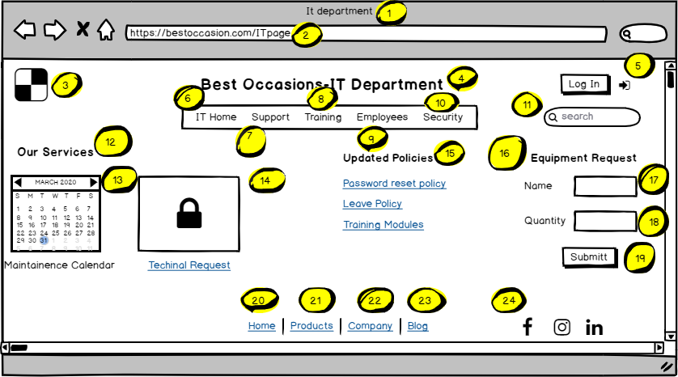

# **Annotations**

|  |  |  |  |  |
| --- | --- | --- | --- | --- |
| Footnote | Label | Description | Control Type | Content Type |
| 1 | Site Name | Name of the site department | Browser Window | Text |
| 2 | Site Path | A hyperlink path for the site | Browser Window | Text |
| 3 | Logo | Logo of the company | Icon | Visual |
| 4 | Title | This is the site title | Label | Text |
| 5 | Login | Allows the user to log in to page | Button | Text |
| 6 | IT Home | Redirects to home page of IT department | Link | Text |
| 7 | Support | Redirects to support team page | Link | Text |
| 8 | Training | Redirects to Training page | Link | Text |
| 9 | Employees | Redirects to employee’s page | Link | Text |
| 10 | Security | Redirects to security page | Link | Text |
| 11 | Search | A place to find content within site | Input | Box |
| 12 | Our Services | Displays all the services present in department | Label | Text |
| 13 | Maintenance Calendar | To let the employees, know when the system will be slow | Image | Image |
| 14 | Technical Request | A place to raise the technical issues | Link | Text |
| 15 | Updated  Policies | Displays the IT Policies | Link | Text |
| 16 | Equipment Request | A place to request for the equipment needed | Label | Text |
| 17 | Name | Name of the equipment | Input | Text |
| 18 | Quantity | Number of units required | Input | Text |
| 19 | Submit | Submits the request | Button | Text |
| 20 | Home | Redirects to home page | Link | Text |
| 21 | Products | Redirects to products page | Link | Text |
| 22 | Company | Redirects to company page | Link | Text |
| 23 | Blog | Redirects to Blog | Link | Text |
| 24 | Social Tools | Helps to get to the social media page of the company where you can follow the page | Links | Visual |

# **References**

Balsamiq (2008). *Quick and Easy Wireframing Tool.* Retrieved on (March 29, 2020) from <https://balsamiq.com/wireframes/?gclid=Cj0KCQjwjoH0BRD6ARIsAEWO9Dst2ypSRj-N0F9Xkx-wUT2KBr_IhIX3jiHihqNsHQODVknHdJQAcd4aAkeaEALw_wcB>